**Appendix to Assignment 7**

**Temperature-dependant Overclosure:**

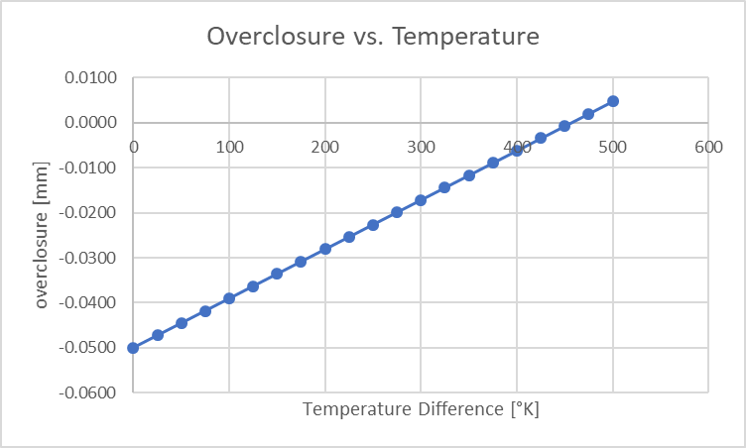

Figure 1

The analytically calculated overclosure during heating (x-axis) shows, that the disc clears the shaft at around 450°K temperature difference (positive overclosure). The maximum value (at 500°K) can be calculated as 0.0047mm. Thus, the maximum initial overclosure needs to be <0.0547mm in order to reach clearance of the two parts at 500°K.

Table 1

|  |  |  |
| --- | --- | --- |
| ẟ°K | disc radius [mm] | overclosure [mm] |
| 0 | 9.950 | -0.0500 |
| 25 | 9.953 | -0.0473 |
| 50 | 9.955 | -0.0445 |
| 75 | 9.958 | -0.0418 |
| 100 | 9.961 | -0.0391 |
| 125 | 9.964 | -0.0363 |
| 150 | 9.966 | -0.0336 |
| 175 | 9.969 | -0.0308 |
| 200 | 9.972 | -0.0281 |
| 225 | 9.975 | -0.0254 |
| 250 | 9.977 | -0.0226 |
| 275 | 9.980 | -0.0199 |
| 300 | 9.983 | -0.0172 |
| 325 | 9.986 | -0.0144 |
| 350 | 9.988 | -0.0117 |
| 375 | 9.991 | -0.0090 |
| 400 | 9.994 | -0.0062 |
| 425 | 9.997 | -0.0035 |
| 450 | 9.999 | -0.0007 |
| 475 | 10.002 | 0.0020 |
| 500 | 10.00473 | 0.0047 |

**Mises Stress at different overclosures:**

We tried 2 additional overclosures, one with 0.025mm and one with 0.01mm. Along with the original overclosure of 0.05mm we achieved following values for the maximum mises stress:

Table 2

|  |  |
| --- | --- |
| Overclosure [mm] | Mises Stress [N/mm2] |
| 0.010 | 224.3 |
| 0.025 | 561.7 |
| 0.050 | 1126 |

Figure 2

The maximum mises stress values can be approximated linearly. Double the overclosure results in roughly double the mises stress. This is only a qualitative estimate.

**Contact Pressures at different overclosures:**

We tried 2 additional overclosures, one with 0.025mm and one with 0.01mm. Along with the original overclosure of 0.05mm we achieved following values for the maximum contact pressures:

Table 3

|  |  |
| --- | --- |
| Overclosure [mm] | Mises Stress [N/mm2] |
| 0.010 | 128.7 |
| 0.025 | 322 |
| 0.050 | 644.6 |

Figure 3

Similarly to the mises stress values, the contact pressures show an approximately linear behaviour.

To avoid plastic deformation, the maximum mises stress needs to remain below the yield stress of the material. With yield stresses of steel ranging between 200 – 300Mpa, we can therefore estimate (from Figure 2 and Table 2) a maximum allowed overclosure of roughly 0.01mm, in order to remain in the elastic region.